

ASSET VERIFICATION AND RECORDING TOOL KIT


Plot 31, Bukoto Street
P.O Box 7657, Kampala, Uganda
+256 (0) 39 2000216/0772525235
email: cpa@cpa.ug

www.cpa.com

August to September 2026

VERIFICATION DETAILS

NAME OF THE REGION: | BUGANDA
SUB-REGION: | CENTRAL
Name of Local Government | KYANKWANZI DISTRICT LOCAL GOVERNMENT
VERIFIER PARTICULARS
Full name | FATUMA YASIN,NAKAGWA HINDU,NAKITENDE SHARIFA
Contact/ email and Telephone | 0703480094,0702578692,0703780913
Supervisor/ Sub team leader | FATUMA YASIN
Name | DEPAUL
Contact | 0788483159
Date of submission

HEALTH CENTRES
INFORMANT INTERVIEW/DISCUSSION GUIDE (INCHARGE OR RESPONSIBLE PERSON)

Name of Health Centre: BANDA HEALTH CENTRE III…

1a | Does the Facility have a record of all assets provided under UgIFT.  (Obtain a record and verify if it has the costs and numbers supplied | NO
1b | If Not ask how many were supplied and when.

2 | How does this facility Maintain (repair/service/replace) the assets provided under Ugift

The facility plans for repairs from within to repair and service the assets provided under UGIFT

3 | Does the facility take regular record about functionality/ or breakdown of the assets provided? | NO, they don’t take any records

4 | How has the UgIFT support helped in service delivery in the area, any issues, challenges and any recommendations for better program implementation. | UGIFT has helped the facility by;  - Improved infrastructure – UgIFT supports construction and upgrading maternity wards.  - Provision of medical equipment – Health centers receive essential equipment for laboratory services, maternity care, immunization and general patient treatment.  - Improved access to healthcare – New and upgraded health centers bring healthcare services closer to communities, reducing the distance and cost of seeking medical care.  - Improved maternal and child health services – the facility is better equipped to provide antenatal care, safe deliveries, immunization and treatment for mothers and children.  - Improved service delivery – Better infrastructure, equipment and staffing enable health workers to provide faster, safer and more effective healthcare services.  Challenges  - There is power shortage at the facility  - The OPD section is small to cater for the big number of patients.  Recommendations  - The suppliers should take time to train the stores person on use of equipment.  - There is need for installation of solar to improve power supply at the facility.

PROCEED TO VERIFICATION AFTER THIS DISCUSSION

Health centre checklist

NAME OF LG………………………………………… NAME OF HEALTH FACILITY…………………………………………………………

Equipment/ Item | Department | Asset Number | Item  Description | Life in Months | Tag Number ( engrave no.) | Date Of Purchase | Date Placed In Service | Recoverable cost | Cost | Acc Dep Cost | Net Book Value | Ytd Deprn | Equipment status | Remarks
B.P. Machine, Digital | OPD |  | It is digital, grey in color |  | No engravement |  | 25/08/25 |  |  |  |  |  | Not functional | Not in use
01
B.P. Machine (Aneroid wall mounted)
Autoclave 20 Liters.,Duo Operated | maternity |  | It is silver bowl with a round top and black handle |  | No engravement |  | 25/08/25 |  |  |  |  |  | functioning | In use
Bowl, Kick | MAT 04  Store 02 |  | Silver basin like bowls |  | No engravement |  | 25/08/25 |  |  |  |  |  | functioning | In use
06
Bowl Stand | MAT 01 |  | Silver basin like with wheel stands |  | No engravement |  | 25/08/25 |  |  |  |  |  | functional | One bowl stand is spoilt
03 | IPD 01
.
Counting chamber Neubauer- Improved
Cupboard Steel, Lockable | MAT 02 |  | Grey in color with compartments and locks |  | No engravement |  | 25/08/25 |  |  |  |  |  | functional | One cupboard doesn’t lock
05 | OPD 02
 | IPD 01
Drip Stand | MAT 02 |  | Silver with 2 hooks |  | No engravement |  | 25/08/25 |  |  |  |  |  | fumctional | In use
03 | IPD 01
ESR Stand
Examination Couch | MAT 03 |  | Cream with a black bed |  | No engravement |  | 25/08/25 |  |  |  |  |  | functional | They are used as delivery beds
04 | IPD 01
Examination light,LED | MAT |  | Black in color |  | No engravement |  | 25/08/25 |  |  |  |  |  | functional | In use
03
Glucometer | LAB |  | White in color with a strip tin |  | No engravement |  | 25/08/25 |  |  |  |  |  | One is functional | One is spoilt,not in use
02
Haemoglobin Meter, Digital | LAB |  | Cream in colour with both inch and cm readings |  | No engravement |  | 25/08/25 |  |  |  |  |  | functional | In use
01
Height Meter | MAT |  | Cream in colour with both inch and cm readings |  | No engravement |  | 25/08/25 |  |  |  |  |  | functional | In use
01
Instrument Trolley | MAT 02
04 | OPD 01 |  | Silver in color with 2 partitions |  | No engravement |  | 25/08/25 |  |  |  |  |  | functional | In use
 | IPD 01
Microscope Binocular | LAB |  | White in color |  | No engravement |  | 25/08/25 |  |  |  |  |  | functional | In use
01
Otoscope
Patient Screen | MAT 03 |  | Silver with blue curtain like clothing |  | No engravement |  | 25/08/25 |  |  |  |  |  | functional | 2 are not functioning
04 | Store 01
Patient Trolley | OPD 01 |  | 4 wheels with a black sponge and 2 handles |  | No engravement |  | 25/08/25 |  |  |  |  |  | functional | In use
02 | IPD 01
Refrigerator, Basic
Stethoscope | OPD 01 |  | White in color with a black top |  | No engravement |  | 25/08/25 |  |  |  |  |  | functional | In use
04 | Store 03
Stop Watch
Stretcher | MAT 01 |  | It has a black soft sponge with wheels |  | No engravement |  | 25/08/25 |  |  |  |  |  | functional | One was taken by district officials
02
Stove, Gas
Weighing Scale with Height Meter, Adult | OPD |  | Cream in color |  | No engravement |  | 25/08/25 |  |  |  |  |  | One is functional 2 are not | 2 got spoilt
03
Weighing Scale, Infant | MAT 01 |  | White with a basin like tray |  | No engravement |  | 25/08/25 |  |  |  |  |  | functional | In use
Weighing Scale, Toddler
Wheel Chair | MAT 01 |  | Black in color with 2-foot pads with wheels |  | No engravement |  | 25/08/25 |  |  |  |  |  | functional | In use
02 | IPD 01
Audio Visual Equipment
Medical Waste Bin | IPD 06 |  | Blue in color and wrapped in polythene bag |  | No engravement |  | 25/08/25 |  |  |  |  |  | functional | In use
06 | MAT 03
Wall Clock | MAT 01 |  | Round and white in color |  | No engravement |  | 25/08/25 |  |  |  |  |  | functional | In use
03 | LAB 01
 | OPD 01
Diagnostic Equipment Set for MCH
Diagnostic Equipment Set for OPD
Glassware Set, Laboratory, Basic
Hollow Ware Set, Treatment | Store |  | Contains glass tools |  |  |  |  | 25/08/25 |  |  |  |  | Still new | Not in use yet
06
Instrument Set, Dressing
Instrument Set, Basic ENT | Store 03 |  | Packed in a silver pan with a polythene |  | No engravement |  | 25/08/25 |  |  |  |  |  | One is in use | 3 are kept in the store
04 | MAT 01
Instrument Set, Suture
Pulse Oximeter, Hand held | MAT |  | Has a screen with a grey cable |  | No engravement |  | 25/08/25 |  |  |  |  |  | functioning | In use
01
Bed, Adult Patient with Mattress
Bed, Pediatric Patient, With Mattress |  |  | White with black sponge mattress |  | No engravement |  | 25/08/25 |  |  |  |  |  | functioning | In use
04
Bedside Locker
Cupboard, Instrument
Delivery Bed, Hydraulic Manual | MAT |  | Black in color with blue sponge mattress |  | No engravement |  | 25/08/25 |  |  |  |  |  | Its broken | Women of the area are so fat for one bed
01
Oxygen Therapy Apparatus, Mininum 45L cylinder | MAT |  | Black in color batch no cm02c112018 |  | No engravement |  | 25/08/25 |  |  |  |  |  | functioning | In use
Resuscitator Manual, Infant, with all Mask sizes
Resuscitator Manual, Adult, with all mask sizes | MAT |  | Huge mask with a tube attached |  | No engravement |  | 25/08/25 |  |  |  |  |  | functioning | In use
01
Suction Apparatus, (Electric)
Nebulizer, Ultrasonic
Oxygen Concentrator, Duo Flow | Store |  | Light grey plastic casing with 2 flow meters |  | No engravement |  | 25/08/25 |  |  |  |  |  | Brand new | Still sealed
01
Bench
Disinfection Buckets | MAT |  | Normal buckets with rounded tops |  | No engravement |  | 25/08/25 |  |  |  |  |  | functional | In use
02
Baby Cot
Diagnostic Equipment Set for Ward
Hollow Ware Set, Ward | Store |  | Rectangular silver container with equipment |  | No engravement |  | 25/08/25 |  |  |  |  |  | functional | Not in use yet
10
Instrument Set, Delivery | MAT 03 |  | Silver pans, scissors of different sizes |  | No engravement |  | 25/08/25 |  |  |  |  |  | 3 sets are in use | 2 sets are not in use yet
05 | Store 02
Instrument Set, Stitch Removing | Store 04 |  | Sealed in a brown box |  | No engravement |  | 25/08/25 |  |  |  |  |  | One is in use | 4 sets are still new in the store
05 | MAT 01
MVA Kit | Store 02 |  | Contains plastic tubes, scissors and other items used in delivery |  | No engravement |  | 25/08/25 |  |  |  |  |  | Still new | Only one is in use now
03 | MAT 01
Stool, Laboratory
Penguin Sucker | MAT |  | Rubber with a Nosal like tube |  | No engravement |  | 25/08/25 |  |  |  |  |  | functioning | In use
01
Fetoscope, Dopplar |  |  | Silver and round with a flat bottom |  | No engravement |  | 25/08/25 |  |  |  |  |  | functional | 2 fetoscope and one dopplar
03
Bubble CPAP
Centrifuge (Electric) | LAB |  | Rounded dome-like with metallic buttons |  | No engravement |  | 25/05/25 |  |  |  |  |  | functional | In use
01
Kangaroo Mother Care Chair
Radiant Infant Warmer
Haemoglobin Meter, Sahli
Delivery Bed
Examination light |  |  | Black in color with a black base |  | No engravement |  | 25/08/25 |  |  |  |  |  | functional | Not in use due to power shortage
03 | MAT
Instrument set, ENT Basic for HCIII
Bag Valve mask (Ambu Bag), Neonatal
Incubator
Office Chair | MAT 03 |  | Grey in color and swinging with wheels |  | No engravement |  | 25/08/25 |  |  |  |  |  | All have broken arms | They were supplied with broken arms
04 | IPD 01
Desk | MAT |  | Wooden large table top |  | No engravement |  | 25/08/25 |  |  |  |  |  | functional | In use
04
Filing Cabinet
Non Residential Buildings | Maternity block
01 | Office block was renovated
Residential Buildings | Staff quarters  block |  | 2 stances each with 2 rooms
 | Toilets
 | Biometrical waste pit |  | Others include;  Placenta pit  Septic tank

PICTURES OF ASSETS VISITED AND VERIFIED

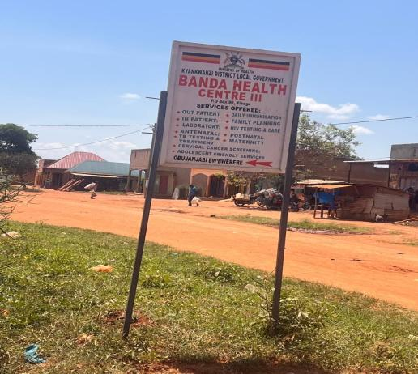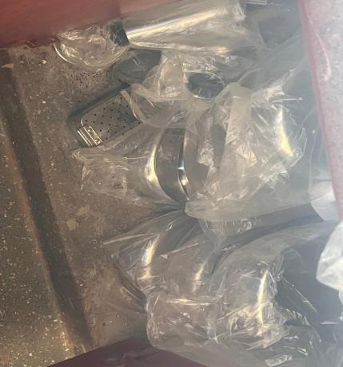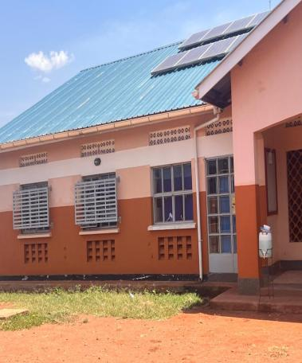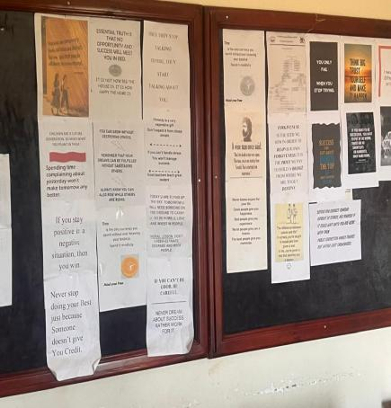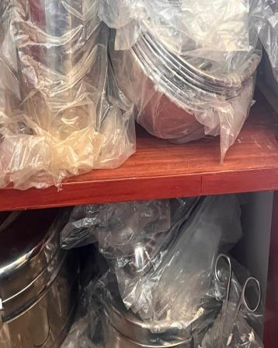
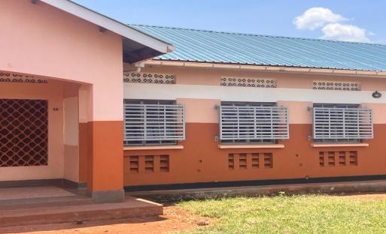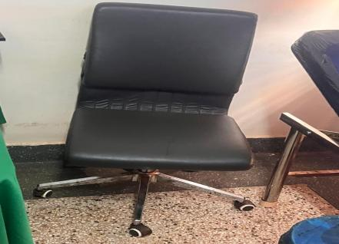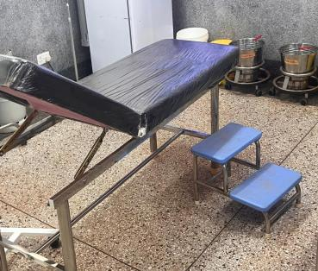

SCHOOL VERIFICATION CHECKLIST

SCHOOL INTERVIEW/DISCUSSION GUIDE

Name of school: ………………………………………………………………………………..

1a | Does the Facility have a record of all assets provided under UgIFT.  (Obtain a record and verify if it has the costs and numbers supplied
1b | If Not ask how many were supplied and when.

2 | How does this facility Maintain (repair/service/replace) the assets provided under Ugift

3 | Does the facility take regular record about functionality/ or breakdown of the assets provided?  Nonfunctional/ working, and reasons for non-functionality.

4 | How has the UgIFT support helped in service delivery in the area, any issues, challenges and any recommendations for better program implementation.

PROCEED TO VERIFICATION AFTER THIS DISCUSSION

SCHOOL FURNITURE
(School Desks, Office chairs, Laboratory stools, Book shelves)

Name of LG………………………………………………………………… Name of SCHOOL………………………………………………………………………………

Equipment/ Item | Department | Asset Number | Item  Description | Life in Months | Tag Number ( engrave no.) | Date Of Pur | Date Placed In Service | Recoverable cost | Cost | Acc Dep Cost | Net Book Value | Ytd Deprn | Equipment status | Remarks

ICT ITEMS TO VERIFY
(Desktop Computer, Server Processor, Network Switch 24 Port, Multipurpose Printer, UPS, Projector, Air Conditioners, Server, CCTV Camera)

Name of LG…………………………………………………………………………… Name of SCHOOL………………………….………………………………………

Equipment/ Item | Department | Asset Number | Item  Description | Life in Months | Tag Number ( engrave no.) | Date Of Pur | Date Placed In Service | Recoverable cost | Cost | Acc Dep Cost | Net Book Value | Ytd Deprn | Equipment status | Remarks

BUILDINGS TO VERIFY
(Non- Residential and Residential, Kitchen, Toilets/Pit latrine Water tanks, Fences etc.)

Name of LG…………………………………………………………………………… Name of SCHOOL………………………….………………………………………

Equipment/ Item | Department | Asset Number | Item  Description | Life in Months | Tag Number ( engrave no.) | Date Of Pur | Date Placed In Service | Recoverable cost | Cost | Acc Dep Cost | Net Book Value | Ytd Deprn | Equipment status | Remarks

